## Program Performance Report

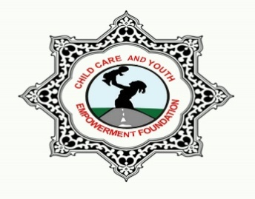

1. **Project Overview**

Market Based Sanitation Implementation Approach (MBSIA) and WASH in Schools (WiS) is a community driven approach aimed at mobilizing and triggering communities/ villages to increase household access to sanitation and water services, and adoption of key hygiene behaviors at home, school, and health facilities. CCAYEF, with support from USAID/ Uganda Sanitation for Health Activity, is implementing this project in Buikwe and Kayunga districts to gain access to a basic sanitation (improved latrines and hand washing with water and soap). Specifically, the project aims at improving household sanitation and water services in 185 villages, with a total of 3,597 households moving from unimproved to improved sanitation status in Busaana Sub-county, 3,618 in Kitimbwa, 489 in Kangulumira, 3,574 in Buikwe Sub-County and 2,247 in Ngogwe Sub-county making a total target of 13,525 households to move from unimproved to improved sanitation status. It also aims at a total of 3,435 households moving from open defecation status in Busaana Sub county, 5,885 in Kitimbwa, 191 in Kangulumira, 2,548 in Buikwe Sub County and 1,348 in Ngogwe Sub county making a total target of 13,407 for households to move from open defecation to basic sanitation status and a total of 8,474 households having Basic Hand washing in Busaana Sub county, 11,940 in Kitimbwa, 772 in Kangulumira, 9,335 in Buikwe Sub County and 5,967 in Ngogwe Sub county making a total target of 36,488 for Households to have basic hand washing facilities as well as increasing adoption and expansion of key hygiene behaviors at home and in schools.

|  |  |
| --- | --- |
| **Name of Grantee:** | Child Care and Youth Empowerment Foundation (CCAYEF) |
| **Contract Start:** | 29th November 2021 |
| **Contract End Date:** | 30th June 2022 |
| **Reporting period:** | 22ndMarch 2022-13th May 2022 |
| **District(s) of implementation and respective sub-counties and parishes** | **District:** Buikwe  **Sub-counties**: Buikwe and Ngogwe  **Parishes:**  **Buikwe Sub-county**; Ssugu, Kikoma – Kitazi and Malongwe  **Ngogwe Sub County**; Lubongo, Ndolwa, Namulesa, Kiringo, Kikwayi and Ddungi |
| **District:** Kayunga  **Sub Counties:**Kangulumira, Busaana&Kitimbwa  **Parishes:**  **Kangulumira Sub-county:**Kikwanya, Seeta-Nyiize  **Busaana Sub-County**; Kiwangula, Lusenke, Namukuma, Nampanyi, Namusaala, Namirembe, Nabugaanyi and Kasana  **Kitimbwa Subcounty:** Kitatya,Kyerima,Nakivubo,Namulaba, Nkokonjeru, Wabuyinja and Wabwoko. |
| **No. of target villages by district** | Buikwe: 94  Kayunga: 91 |
| **Milestone No:** | 14 |

**Executive Summary:**

This 14th milestone - end of project report covers activities under the MBSIA for the reporting period started 29th November 2021 to 30th June 2022. It also focuses on the reflections, best practices, success stories and lessons learned constraints from Phase II and Phase III. These include the following; Targeted follow up visits with households of triggered 185 villages, 73 for Ngogwe, 36 in Busaana, 6 for Kangulumira, 49 in Kitimbwa and 21 for Buikwe Sub-county, Door-to-door sales of sanitation products by sanitation promoters, Districts’/Sub-Counties entry and exit meetings, training of both the DLG Technical and strategic Team for Buikwe and Kayunga Districts on MBSIA model ODF verification, joint monitoring visits and support supervision to project villages/Sub-counties to track progress by the PC, M&E, ED and the FO.

**2.0 Summary of the key milestone for the reporting period and key achievements of the milestone:**

|  |  |  |  |
| --- | --- | --- | --- |
| **Milestone No.** | **Milestone Requirements** | **Target** | **Achievements** |
| 14 | Sub-County exit meetings held for both Kayunga and Buikwe Districts with evidence of attendance lists and photos for the meetings. | Reports for the meeting | Report attached |
|  | Sustainability strategies and plans developed per Sub County and Districts of operation. The reports shall highlight clear roles Sub-Counties will do and what the districts needs to do to sustain USHA’s results | Reports for the meeting | Report attached |
|  | Final summary with reflections, best practices, success stories and lessons learned from Phase II and Phase III. |  | They are embedded in this report |

* 1. **Summary of results for the reporting period and key achievements**:

**In this report, focus was made on accomplishment of the 14thmilestone report;**

1. Sub-County exit meetings held for both Kayunga and Buikwe Districts with evidence of attendance lists and photos for the meetings.
2. Sustainability strategies and plans developed per Sub County and Districts of operation. The reports shall highlight clear roles Sub-Counties will do and what the districts needs to do to sustain USHA’s results.
3. Final summary with reflections, best practices, success stories and lessons learned from Phase II and Phase III.
   1. **Summary of results for the reporting period and key achievements**

| **Key Result Area (Indicator):** | | **Baseline Value** | **Planned Target (Contract period)** | **Planned target (reporting period)** | **Achievements during reporting period** | **% of variance between target % achieved** |
| --- | --- | --- | --- | --- | --- | --- |
| Number of people gaining access to basic sanitation service. | % of HHs with unimproved latrines and without latrines (to be moved to basic) | Kayunga:  17,216  Buikwe:  9,717  Total:  26,934 | Kayunga:  1,720  Buikwe:  1,720  Total:  3,440 | Kayunga:  1,720  Buikwe:  1720  Total:  3,440 | Kayunga:  2,076  Buikwe:  1,990  Total:  4,066 | Kayunga:  21%  Buikwe:  16%  Total:  18% |
| % of households without latrines to be moved from OD. | 13,408 | 4,571 | 4,571 | 4,571 | 0% |
| No. of villages reached through MBSIA/CLTS. | | 185 | 185 | 185 | 185 | 0% |
| No. of villages verified as Open Defecation Free (ODF) through MBSIA/CLTS | |  | 48 | 48 | 55 | 15% |
| % of households with water and soap at hand washing station commonly used by family members | | 36,488 | 4,721 | 4,721 | 5,716 | 21% |
| No. of community stakeholder platforms used in planning, execution and learning | | N/A | - | - | 03 | N/A |

* 1. **Constraints and critical issues:**

|  |  |  |
| --- | --- | --- |
| **N/o** | **Challenges** | **Action** |
| 1. | Failure to find decision makers for latrine construction at home especially for OD households | Finding (them) OD households at their places of work for example gardens, centers, farms and empower them to construct latrines in their homes. |
| 2. | Most households are reluctant to fit doors for their latrines thus making their latrines to remain unimproved especially those moving from OD. | Privacy was emphasized privacy thus triggering more households to adapt to the system of fitting doors on their completed permanent latrines. |
| 3. | Most married women in villages of Kitimbwa still have a mentality that it’s a responsibility of men to construct latrines at home. | Continuous sensitization to the married women and to all women to understand that a latrine benefits all people at home therefore it’s a responsibility of all household members to participate in its construction |
| 4. | Postponement of scheduled dates for joint monitoring visits and entry meetings by District and Sub-county officials thus causing delays in meeting the timelines for the project. | To be well acquainted with work schedules for the district and Sub-county officials. |
| 5. | Failure to find decision makers for latrine construction at home especially for OD households | Finding (them) OD households at their places of work for example gardens, centers, farms and empower them to construct latrines in their homes. |
| 6. | Difficulty in convincing the non-trained mason to participate in the interview | We explained the purpose of the interviews to the mason through the SP for Kangulumira Central Zone and that motivated him to participate in the exercise. |

1. **Activity Implementation to achieve milestones and project results:** 
   1. **Community sanitation:**

**The results achieved include the following:**

1. Conducted sustainability assessment interviews for value chain actors and captured learnings from Phase I Sub County (Kangulumira): 4 masons and 6 SPs (3 were females and 3 males) participated in the interviews. They shared the experiences they had encountered in the respective villages. A report was shared.
2. 48 villages for CCAYEF have been verified as ODF; 23 in Buikwe district (21for Ngogwe Sub-county and 02 for Buikwe) and 25 in Kayunga (Busaana 07, Kitimbwa 17) and 01 for Kangulumira.
3. Conducted a training for the Districts Local Government technical staff for both Kayunga and Buikwe Districts on 25th and 26th April 2022 at Nile Hotel_Njeru in Buikwe District and orientation workshops for District Local Government strategic stakeholders/leaders on 27th April for Kayunga team at Katikomu Hotel_ Kayunga and 28th April, for Buikwe at Castle in Hotel- Lugazi. They appreciated USHA/CCAYEF for the work done in their respective districts and Sub-Counties through the MBSIA, it has improved on the sanitation and hygiene of the people, they also acquired knowledge and skills to enable them continue with the project after the project’s closure and commitments/action plans for scaling up MBSIA in the targeted Sub-Counties and beyond were also made.
4. Conducted follow up visits in the targeted villages with the help of government officials who could awaken and also give deadlines of constructing latrines to stubborn households to register more ODF villages and attain basic sanitation in all the targeted villages for all the Sub-counties; 94 for Buikwe district (73 villages for Ngogwe sub county and 21 for Buikwe sub county) and 91 for Kayunga district(6 for Kangulumira, 36 for Busaana and 49 for Kitimbwa Sub county) to support Sanitation Promoters to maximize sales for sanitation products, referral of interested households to the masons and also continuous door to door visits to targeted households especially the reluctant/stubborn households to re-awaken in order for them to improve upon their sanitation status. 19 villages are soon becoming ODF, and these include Bogo from (Ngogwe Sub-County), Kitatya A, Mafumbe, Mansa A, Nongo-Nakivubo and TweyagalireA in( Kitimbwa sub county) then Wampongo, Nabuganyi, Namatogonya, Nekoyedde, Bukungulu, Kireku-Nampanyi, Nakakandwa, Nampanyi, Kitala, Nanyuki and Namutya in (Busaana Sub- County). Wantayi (Kangulumira Sub County).
5. Conducted Phase III entry meetings for stakeholders at Kayunga and Buikwe Districts and the 4 targeted Sub-counties of Kitimbwa, Busaana (Kayunga Districts) and Buikwe and Ngogwe (Buikwe District) to communicate about follow up of Phase III of the project and agree on status of achievements, work plans, timelines and key deliverables as well as key roles and responsibilities of stakeholders. Districts and Sub-County officials worked with CCAYEF team to achieve the project results for Phase III.
6. Conducted joint monitoring visits for Kayunga and Buikwe Districts in 17 villages: Mansa B Kirimampokya B, Wabuyinja, Wabuti, Kyetume A and Kyetume B villages for Kitimbwa, Bukungulu, Kasota and Kyengera for Busaana Sub-County, Malongwe for Buikwe Sub-County and Gamba,Bubiro, Bulutwe A and Bulutwe B, Kibali, Mawoloba and Buwooya for Ngogwe; all 14 out of 17 villages became ODF.
7. Conducted all actors meetings for Buikwe and Ngogwe Sub-counties; 69 participants attended the meeting for Ngogwe (50 females and 19 males) and for Buikwe, 24 participants (14 females and 10 males), Busaana 42 (25 males and 17 females), Kitimbwa 58 (38 males and 20 females). The SPs were trained on how to conduct sales pitch to households with difficult soils and the trained masons taught the SPs the different types of latrines that are constructed in areas with difficult soils; rocky, high water tables and collapsing soils including the estimated costs for constructing such latrines.
8. Conducted exit meetings for Sanitation Promoters for Busaana, Kitimbwa,Buikwe and Ngogwe Sub-Counties; 72 participants attended the meeting for Ngogwe (13 males and 59 females),21 for Buikwe (10 males and 12 females),Busaana 42 (25 males and 17 females), Kimbwa 58 (38 males and 20 females). The masons and SPs appreciated USHA and CCAYEF and they are willing to continue conducting door to door sales visits to the pending targeted homes to create demand for sanitation products once a week because most of them were working as VHTs before the project and the masons also committed themselves to continue constructing new latrines/upgrading existing ones to all the households that will express interest.
9. The Finance Officer made monitoring visits to Buikwe and Kayunga field offices to support staff account for the funds received and to carry out assets inventory verification. The PC also supported staff in Ngogwe Sub-County_Buikwe District by working hand in hand with the Health Assistants and parish chiefs to support the Sanitation Promoters for Kayunga and Buikwe on how to empower households to construct/upgrade existing latrines.
10. The M&E also visited OD households in Nakatyaba, Kibali, Buwooya village for Buikwe Sub-County and Kyetume B in Kitimbwa and Bukungulu village in Busaana to verify results for households that constructed latrines from OD to improved and unimproved to improved sanitation status.
11. Participated in the learning visits in the villages of Kasana II (Busaana Sub-county in Kayunga District and Nakatyaba for Buikwe Sub-county in Buikwe District where visitors from USAID,UNICEF, Ministry of Health, Ministry of Water and Environment and other CSOs like BUVAD, AWS and World Vision together with Kayunga and Buikwe District officials learnt about the implementation of the MBSIA model in our targeted Sub-counties. CCAYEF selected villages for the learning visits and also mobilised households to participate in the visits and the District Local Government officials through the Health Assistants for Busaana and Buikwe made follow up visits to the targeted villages and emphasized the need for households to properly use their constructed latrines and hand washing with water and soap in order to sustain the ODF status.
12. Behaviour change messages were read out on local radios of Kitimbwa, Busaana, Buikwe and Ngogwe Sub –Counties targeting ODF villages to make awareness to the residents of those villages about proper latrine usage and their responsibility to ensure good sanitation in their homes. The Sub – County of Kitimbwa promised to adopt the strategy of reminding households about proper sanitation and hygiene through their local radios. CCAYEF identified the different local radios, designed announcements with behavior change information; proper latrine usage, cleaning and use of hand washing facilities and these announcements were read out through the local radios for a period of 2 weeks on different days.

| **Project Component** | **Activity Description** | **Stakeholders targeted by Activity** | **Expected Outcome of Activity** | **Dates of Activity** | **Location information** | | | | |
| --- | --- | --- | --- | --- | --- | --- | --- | --- | --- |
| **District** | **Sub County** | **Parish** | **Village / venue** | **Attendance**  **M F Total** |
| MBSIA | Joint monitoring visits with district and Sub-county officials | ADHO,DHI, ADWO, Health Assistants and Parish chiefs | ODF villages and basic sanitation | 10th and 11th April and 5th May | Kayunga | Kitibmwa | Wabuyinja, Kitatya and Wabwoko | B, Kyetume B &Bwamiramira,  Wabuti | M:06  F:00 |
| Buikwe | Ngogwe | Kiringo,  Ddungi  Lubongo | Mawoloba, Bulutwe B, Gamba, Bubiro, Kasi, Kiwale, Nyemerwa B | F: 00  M: 02  CCAYEF Staff  F: 02  M: 01 |
|  | Conducted review meetings with officials from Kayunga District, Busaana and Kitimbwa Sub-county to discuss the progress of the project. | Health Assistants, CDOs, Senior Assistant Secretaries,  Parish chiefs, LC III Chairpersons,  Head Teachers | Action points from stakeholders on how to continue to implement WASH using the MBSIA model in Phase III and after the project closure | 28th and 29th Feb 4th, 6th, a 7th April 2022 | Kayunga | Busaana and Kitimbwa |  | Sub-County hall and Wabwoko Town Council for Kitimbwa | Busaana  M:6  F:9  Kitimbwa  M:11  F:10 |
|  | Conducted Two Tier ODF Verification | Principal Health Inspector, ADWO/S, Health Inspectors and the Health Assistants | Verified ODF villages | 28th and 29thFeb,29th,30thMarch and 10th, 11th and 12thMay | Buikwe | Buikwe and Ngogwe | Namulesa, Kiringo, Lubongo,  Ddungi | 23 villages | F: 01  M:05 |
|  | 29th,30th March and 10th, 11th 12th ,25th and 26th May 2022 | Kayunga | Kangulumira  Busaana, Kitimbwa | Wabuyinja, Kyerima, Wabwoko,  Namulaba  Kitatya  (Kitimbwa)  Kiwangula,  Nabuganyi,  Lusenke,  Namukuma (Busaana) Kikwanya (Kangulumira) | 25 villages | F: 00  M: 02 |
|  | Conducted Phase III entry meetings for stakeholders at Kayunga and Buikwe Districts | CAO, LCIII, DWO, DHO, DIS, DEO, DHI | Commitments from stakeholders to support the project implementation in Phase III | 9th February 2022 | Buikwe | N/A | N/A | Buikwe District water boardroom | F: 5  M:8 |
|  |  |  |  | 2nd February 2022 | Kayunga | N/A | N/A | Kayunga District Council hall | F: 06  M: 08 |
|  | Carried out learning visits, in the selected villages one for each district of Buikwe and Kayunga to practically understand the MBSIA model. | LCV, , DWO,DCDO,  ADHO,ADWO  Independent consultants, PSWO, Senior Sociologist,HI,HA | Gaining hands-on knowledge and skills on MBSIA model | 28th April 2022 | Buikwe | Buikwe SC | Ssugu | Nakatyaba | Embedded in the DLG training report |
|  |  |  |  | 29th April 2022 | Kayunga | Busaana | Kasana | Kasana II | Embedded in the DLG training report |
|  | Conducted sustainability assessment interviews for Phase I Value Chain Actors | SPs and Masons | Capture learnings from Phase I | 28th January 2022 | Kayunga | Kangulumira | N/A | Kangulumira Town Council | F: 03  M: 07  CCAYEF Staff  F: 02  M: 01 |
|  |  |  |  | 28th Jan 2022 |  |  |  |  |  |
|  |  |  |  |  |  |  |  |  |  |
|  |  |  |  |  |  |  |  |  |  |

* 1. **Reporting on Gender and Gender Based Violence (GBV)** –

Elderly, men, youth and children participated latrine construction and ensuring proper hygiene in their homes as follows;

1. **Youth**

A youth (male) who is a tailor in Nangunga village _Ngogwe Sub-County was captured as OD at baseline but currently, he constructed a permanent latrine and installed a SATO on it. In Lubongo village for Ngogwe Sub-county a also youth appreciated the need to upgrade their existing latrine at home and he made the floor for their one stance latrine washable and also fitted a door. Also in Kigalama village kitimbwa S/C, this village had very many young men (Bodaboda riders and chapatti sellers) who had no latrines at their homes claiming they come back late in the night and leave very early in the morning but through constant follow up even at their places of work they managed to construct latrines made of wattle and mud and some ended up upgrading both latrines through the USHA trained masons.

1. **Elderly**

In Namulesa an elderly lady, who was enumerated as OD at baseline, was supported by her grandson who is a mason to construct a permanent latrine with 2 stances which they are currently sharing. In Nangunga an erldelywho was at OD constructed a latrine with mud and wattle due to constant follow up. She used the savings from her business of rearing pigs to upgrade her latrine by making the floor washable. In Wanteete A two old men (peasant farmers) who were at OD constructed latrines with mud and wattle; one elderly was supported by the grand daughter to collect water for construction from the well while the other collected the water himself and also constructed his latrine.

1. **Widow**

In Wabusonko village-Busaana Sub-County a widow constructed a latrine herself with mud and wattle and later on upgraded the floor to become washable using her savings from her local brew business. The pit for the latrine was dug by her grandson aged 15.In Wabwoko village a widow who was captured as OD at baseline constructed an improved latrine and installed a SATO Pan on it. **A list of all the vulnerable people that have constructed latrines or tagged on consent is attached**.

1. **Innovative financing models:** 
   1. **Community sanitation (MBSIA):**
2. ***Ms. Ndiyona Zerida a member of Nezikookolima VSLA Group in Nkokonjeru tells her story***

She is aged 46 years old, from Wabwoko A village, married to Yana Ivan, a primary teacher at Wabwoko CU Primary School. During baseline, this household was captured as OD because the latrine they initially had was already filled up. During the follow up visits made CCAYEF field staff and the Sanitation Promoter in this village, when they visited this household, had made no progress in terms of latrine construction, they put the structure down and when Ms. Zerida came back home and found her latrine down, she was triggered to borrow money from her VSLA group to construct a new latrine. She borrowed 900,000/- and contracted a USHA trained mason Mr. Tembo Ronald to construct for them a permanent latrine. She is expected to pay the money back within 6months. Their saving group has 36 members (16 are males 20 females) and meets fortnightly on Sundays. Currently, she has a permanent latrine constructed pending doors and she plans to fit the doors very soon.

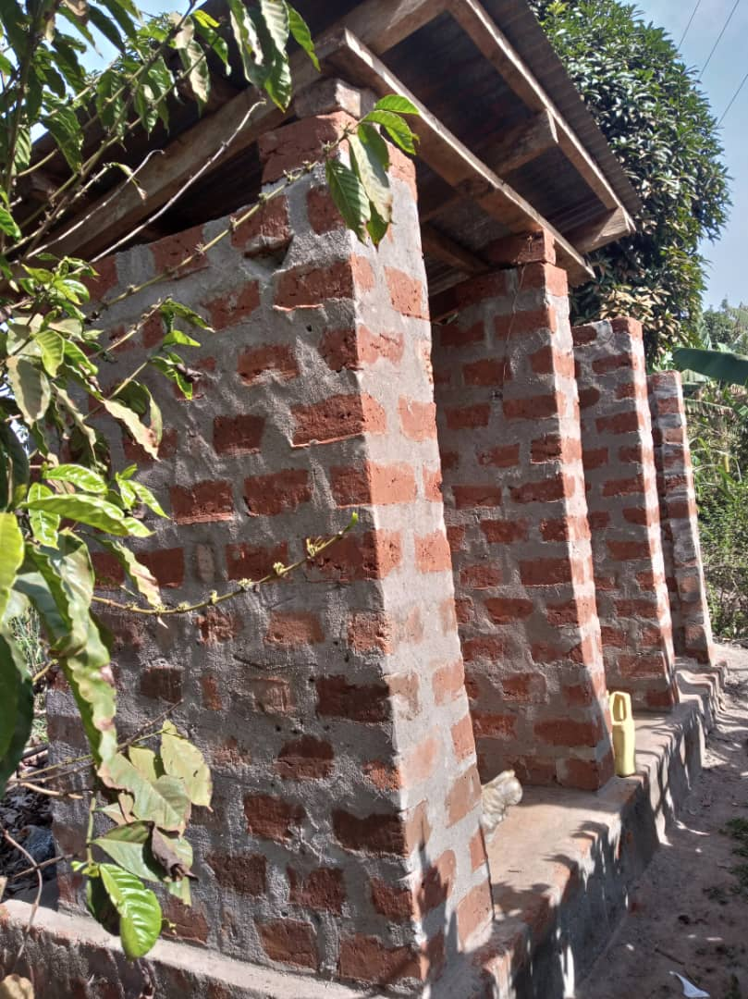

***A latrine constructed by USHA trained mason at Mr. Yana Ivan’s home in Wabwoko A village.***

1. Grouping/clustering households according to their sanitation needs more especially households with unimproved latrines (pending washable floors) to clear their paths in order for them to address their sanitation status. This financing model has so far worked in 9 villages of Busaana; Wabusonko, Kyengera, Kasana II, Namukuma, Kireku-Lusenke, Namirembe, Kibuzi, Nangabo, Bunzibiridde, 9 for Ngogwe Sub County; Busegula, Vvule, Buira, Kikwayi, Buiri, Kiwale, Kikuba, Nyemerwa B and Maseke villages 4 villages in Kitimbwasubcounty: Kakoola, Bulawulaa,Kyatto and Kyetume C and 1 village for Kangulumira Sub County; Kayunga. A group of 10 households contribute 3000 per each household totaling to 30,000/- for them to get a bag of cement. They are supported by CCAYEF to purchase and transport this cement from the hardware stores and it’s kept at the SP’s place that later connects them to the USHA trained mason. 19 villages have benefited to date and 26 bags of cement have been purchased amounting to 780,000/= 9 villages for Busaana have so far formed 1 group per village comprising of 10 people and 9 villages for Ngogwe also formed 2 groups per village. Currently, 150 households have benefited from the clustering strategy.

**Budget performance:** Budget performance is attached.

1. **Collaboration with local and national government, other donor projects, or other USAID projects (1 page).**
   1. **Links with government agencies (e.g. District Local Governments-DLGs through the District Water and Sanitation Coordination Committees-DWSCC):**
2. CCAYEF participated in 2 District Water and Sanitation Coordination meetings; 1 for Kayunga and the other for Buikwe in preparation for the Sanitation Week and World Water Day celebrations. Accomplishments and results attained for the previous year were also shared with stakeholders.
3. CCAYEF participated in the commemoration of the sanitation week and National Celebrations for World Water Day in Luuka and World Water Day celebrations functions organized by Buikwe and Kayunga districts respectively. CCAYEF participated in the commemoration of the sanitation week and National Celebrations for World Water Day in Luuka with the theme: ***Good Sanitation and Hygiene for Strengthening COVID-19 response*** and the theme for Buikwe: Ground water, making the invisible visible and Kayunga: ***Water for Sustainable Development.***
   1. **Links with other donor agencies:**  There were no links made with other donor agencies.
   2. **List and discuss links with other USAID projects:** There were no links made with other USAID projects.
4. **Lessons learned:**
5. Continuous sensitization on sanitation through follow up visits to targeted households enables them to appreciate the need for them to construct latrines in their homes.
6. Joint monitoring visits with District and Sub-County officials to the targeted villages also enables targeted OD households and those with unimproved latrines to understand the need to improve upon their sanitation status because of the respect they have for their leaders.
7. Setting equal targets for field staff motivates them to work harder towards achieving planned targets and milestones in the shortest time possible.
8. Finding household heads at home enables targeted households to complete the sanitation ladder in a short period of time. This was evidenced by the number of households that upgraded/constructed new latrines during the 42 days of lockdown ( June to Mid July)2021 because we were able to find the households heads at home.
9. **Management and Administrative Issues:** There were changes made in this area; Two staff; Malemo John, WiS Officer for Kayunga District, did not apply for Phase III and Muliira Joshua, Sales Catalyst for Busaana, got another job opportunity and resigned. The targets for Phase III were shared equally amongst the current staff and CCAYEF achieved all the set targets.
   1. **Adaptation of the activity**:
10. CCAYEF through the village based Sanitation Promoters has continued to utilize updated village lists to the households still at OD and those with unimproved latrines and most households have completed their latrines and others upgraded their existing ones. The lists of balances for the OD households and those with unimproved latrines were shared with the Sub-Counties and the Districts of operation.
11. CCAYEF has continued to engage the SPs to conduct door to door activities for Phase III of the project basing on the already adopted performance based contract.
12. CCAYEF has also adapted to the using of USHA trained masons at parish level to train other interested builders thus making supply chain more reliable and effective. They are 09 masons that are being trained (hands on); 3 for Kitimbwa, 1 for Busaana, 3 for Ngogwe and 2 for Buikwe Sub County. Additionally, 5 masons were trained by USHA trained masons on how to make movable slabs and san plats in Nyenga Division _Buikwe District in March 2022 during the Sanitation Week and the District through the Water office, equipped them(newly trained masons) with moulds.
13. CCAYEF has opted to the use of volunteers to conduct follow up visits in the targeted villages to enable us register results in a shortest period of time. They were oriented on the work and the required results; they were totaling to 6 volunteers; 4 for Kayunga and 2 for Buikwe district.

**Work schedule with progress to-date and Planned Activities for Next Reporting Period:** Work schedule with progress to date and planned activities are embedded in the Annex for table II

**Success Stories and photos:**

**Testimony from Mr. Sebagudde Charles (PWD) who digs pit holes for households mainly in Buwoya village of Ngogwesubcounty tells his story**

When interviewed by the sales catalyst Ngogwe, he said it is his job and he does it to earn a living as well as promoting sanitation in the area .Based on my physical status, i thought of what I could do to earn a living as well as serving my country farming failed because digging in the garden while your sitting is hard but digging a pit hole is kind easy. I have two children to look after yet I have no wife at home. When I approach people to give me business they under estimate me because of my disability but for those who give me a chance to work for them they appreciate though some people paying me becomes a problem to them and yet I also do it to earn a living for my family. The money I get from my job I use it to invest in my garden so as to get food for my family. Buwoya is growing at fast rate and the demand for latrines is also high and my job is less competitive as most people take pit digging as a job for the poor people. He encourages every citizen to at least have a one stance latrine at home and we shall chase away some diseases in Uganda

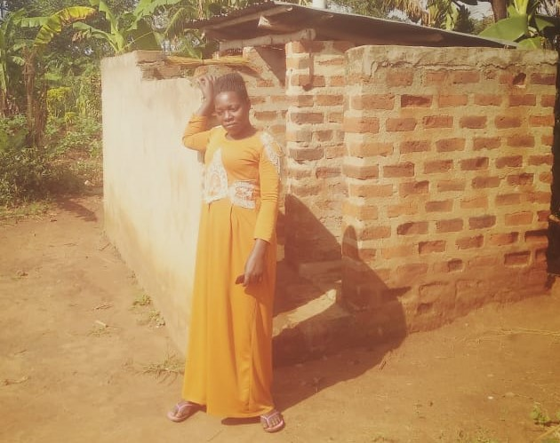

Improved latrine for Mbeiza Specioza the Sanitation promoter for Mansa B village in Kitimbwa Sub- County.

***Success story 1: MbeizaSpecioza (SP) Mansa B village tells her story***

MbeizaSpecioza, aged 35 and a mother of 4 children and Sanitation Promoter forMansa B village in Namulaba ParishKitimbwa sub county Kayunga district.Spesioza is also a member of the local council committee in her village (vice chairperson).At baseline, Mansa B bad 17 households with improved latrines, 60 with unimproved latrines and 128 households were open defecating. She started working as an SP in April 2021and she has moved all her targeted OD households (128) to Open Defecation Free (ODF) 36 of these have basic latrines. She has also made 29 households upgrade their latrines to basic totaling to 65 households attaining basic sanitation.She said that due to her position as the vice chairperson, people respect her thus an enabling factor towards her success. The desire to make her village ODF motivated her to make continuous follow up visits to all OD households to remind them construct latrines in their homes including the chairperson of the village.The SP quoted saying that” The general sanitation of my village has improved, most households have adopted the practice of cleaning their compounds and latrines daily before going to the gardens and householdshave reported reduced visits to the health centre due to diahorrea. Thanks go to CCAYEF/USHA for this project that has transformed the lives of our people”. She (SP) plans to continue making follow up visits to the targeted 101 households with unimproved latrines in order for them to attain basic sanitation in her village.

***Success story 2: Naggayi Afuwa _Sales Catalyst Kitimbwa tells the story of Kitimbwa B village***

Kitimbwa B village is one of the villages in Kitimbwa Sub-county, Wabuyinja parish which had the largest number of households practicing open defecation.The village had 536 households on OD and all of them constructed latrines. 509 out of the 536 households constructed permanent latrines. This success was realized through the constant follow up visits made by the Sanitation Promoter (Were Muhammed) and the chairperson ( Mr. Kamya Abdul) together with the CCAYEF field staff. During the trigger meeting, the people in this village were touched by the many black dots in their village map and majority of them embarked on the construction of latrines in their homes.

***Success story 3:* *Chairman for Kasana II village, Busaana S/C tells his story***

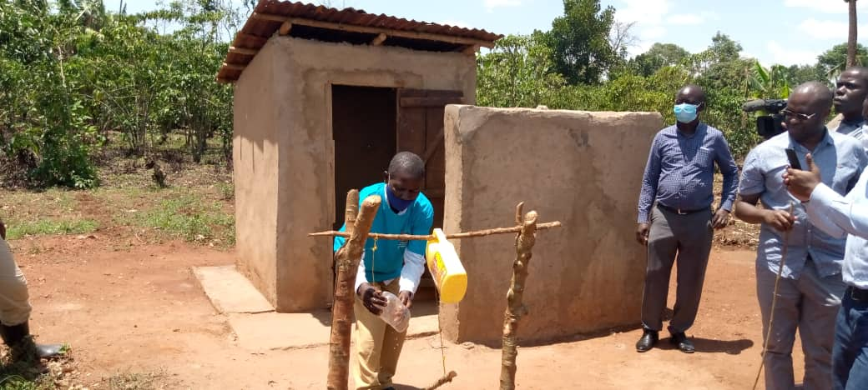

"Before the inception of the project, I did not have a latrine in my home and was among the OD households however, after the trigger meeting I understood the benefits of having a latrine and I currently, constructed a permanent latrine in my home (one stance) with a SATO pan installed and a hand washing facility, thanks goes to CCAYEF and USHA".

Activity photos

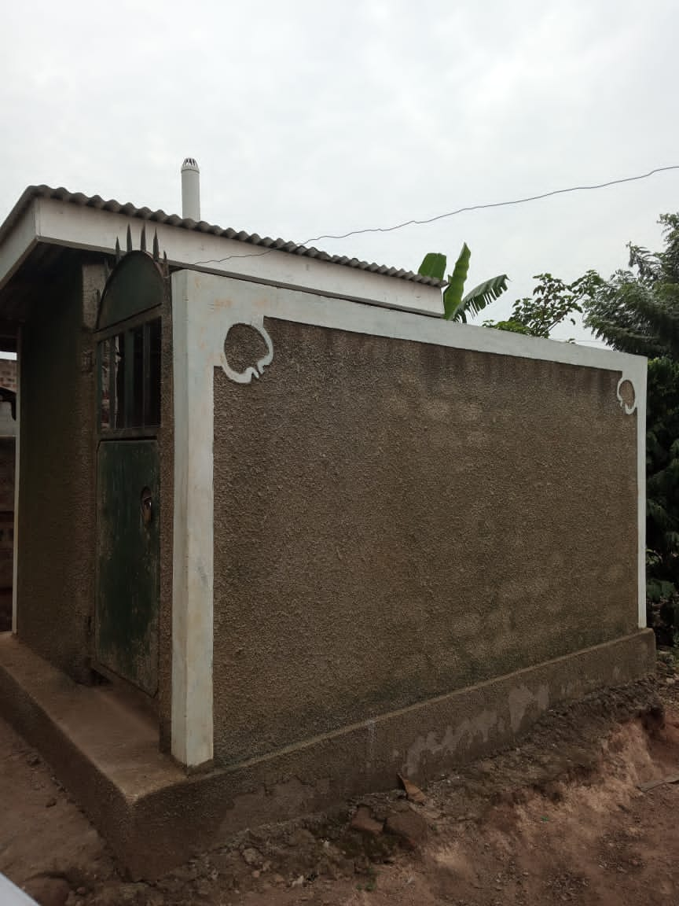

1. OD to improved latrine in Kitimbwa B village_Kitimbwa Sub County. This household was captured as OD at baseline but due to constant follow up visits by the SP together with the field staff, they constructed a permanent latrine.

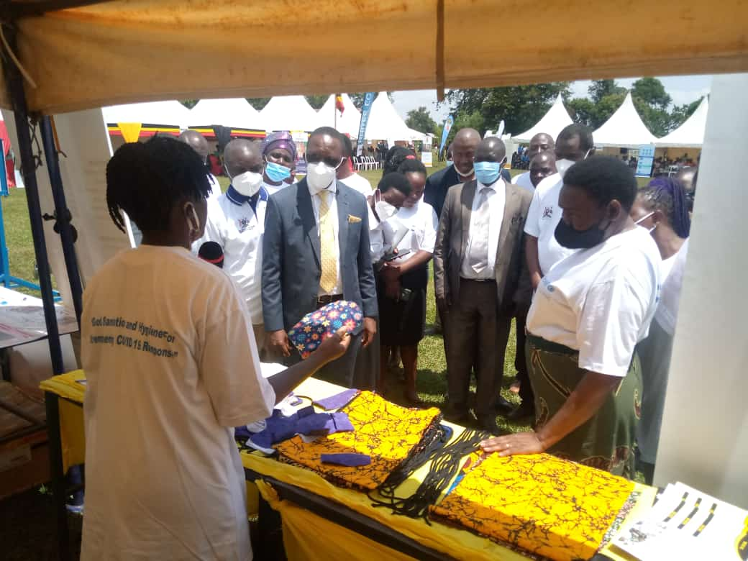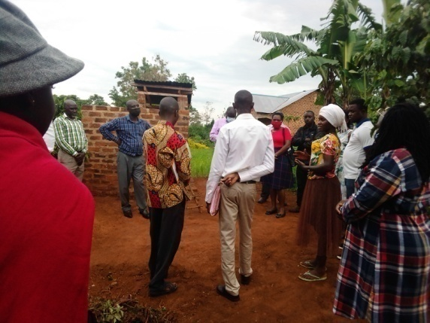

b) Staff showcasing MHM materials c) Visitors during the field learning visits to learn

during the WWD celebrations in Luuka the MBSIA model in Kayunga Kasana II village

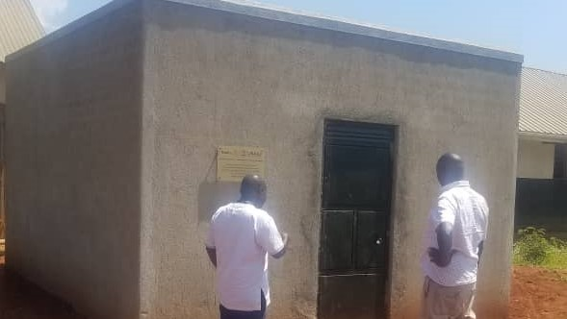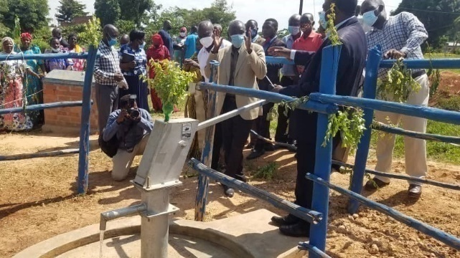

1. **Water tank for Nongo C/U e) RDC commissioning borehole at Bulawula P/S**

The photos are for the tank of Nongo C/U and borehole for Bulawula P/Sin Kayunga district kitimbwa Sub County which were handed over to the school committee by the RDC of Kayunga district on the world toilet day celebrations held on 18/November/2021 at Nkonkonjeru R/C primary school in Kitimbwa Sub-county.

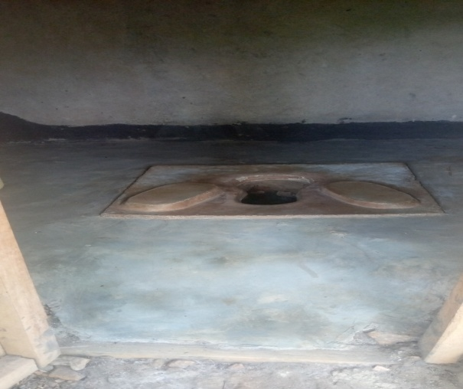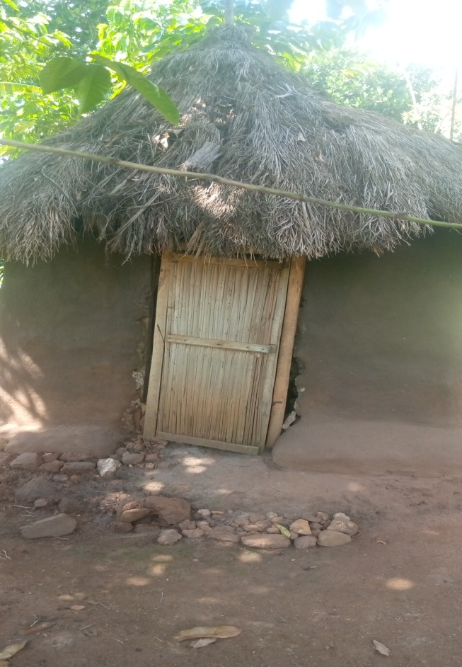

f)This household is found in Nekoyedde village in Busaana Sub-county. Their latrine was captured as unimproved at baseline however; the household head and his wife lacked knowledge of upgrading their unimproved latrine to become improved in nature. After acquiring this knowledge from the Sanitation Promoters and also the field staff, the wife in this home contracted a village based mason and upgraded the floor of their latrine and it became improved in nature because it was only lacking one parameter and she also promised to un-roof the latrine and roof it again with iron sheets for it to become long lasting. Her current latrine is neat with no smell and flies in it and she said she uses ash to prevent the smell and flies in her latrine. Raymond Bolo household head.

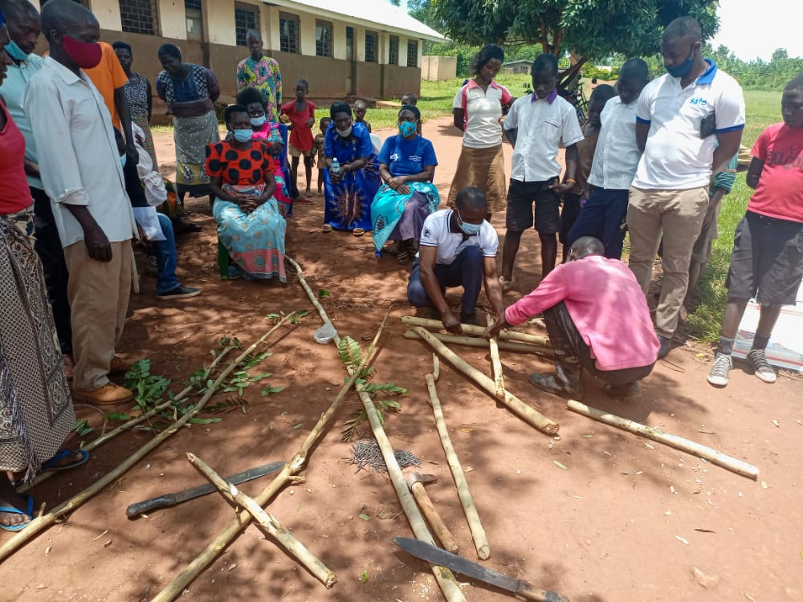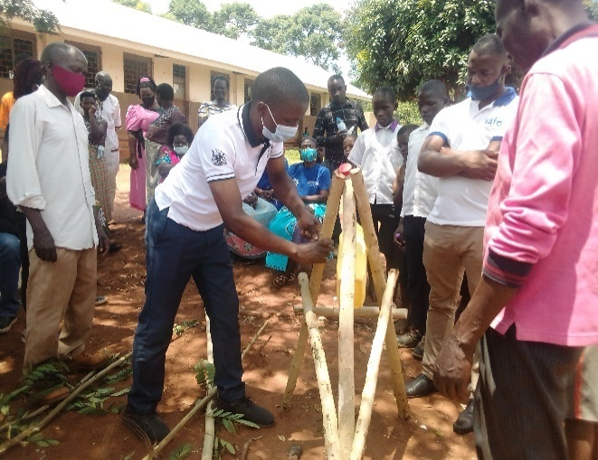

**g)Global Hand Washing day celebrations**

This photo shows participants (households)from Kireku_Lusenke, Kireku_Nampanyiand Bugaddu Blearning how to make a three legged tippy tap (mobile handwashing facility) during the Global Hand Washing Day. The celebrations took place on 15thOctober at Kireku CU Primary School in Busaana Sub-county_Kayunga District. Participants appreciated USHA/ CCAYEF for training them how to make a mobile handwashing facility because it was going to solve the problem of theft jerrycans and they pledged to make them in their homes and also train their neighbors.

. **ANNEX I: ANALYSIS OF ANNUAL PROGRESS ON RESULTS AGAINST TARGETS**

| **Planned Goals and Objectives** | **Planned Target (Contract period)** | | **Progress To-date** | | **% of variance between target and progress (result)** | | **Key Planning for Next Period** | | | |
| --- | --- | --- | --- | --- | --- | --- | --- | --- | --- | --- |
| **Q1** | **Q2** | **Q3** | **Q4** |
| **%** | **Absolute value (based on baseline)** | **%** | **Absolute value** | **%** | **Absolute value** | **(Expand to include specific dates/month for accomplishment)** | | | |
| **Goal:** Increase HH access to basic sanitation and promote adoption of key hygiene behaviors up to 185 villages in Kayunga and Buikwe Districts. | 100% of HHs adopt positive hygiene behavior such as hand washing with soap after toilet use. | 36,488(Contract period) | 16 % | Phase III: 5,716 | 84% | 30,772 | - | - | - | 30,772 |
| HHs moved from unimproved toilets to basic sanitation | Unimproved HHs Phase III – 13,526 | 17% | Phase III –2258 | 83% | Phase III – 11,338 |  |  |  | 11,338 |
| All OD HHs (100%) moved from OD | Phase III: 13,408 OD Households | 20% | Phase III: 2,741 | 80% | Phase III: 10,686 | - | - | - | 10,686 |
| To increase HH access to basic sanitation in Kayunga and BuikweDistricts by May 2022 | 100% target SPs selected and trained | 185 Sanitation Promoters trained on MBSIA | 100% | 185 SPs | 0%  0% | 0  0 | -  - | -  - | -  - | -  - |
| 100% Village Action Plans developed, per village. | 185 Community Action Plans (CAPs) implemented | 100% | 185 CAPs | 0% | 0 | - | - | - | - |

The above figures in the Planned Target (Contract period), Progress To-date and % of variance between target and progress (result) are based on the overall baseline values for unimproved 13,526 and OD 13,408.

**ANNEX 2: WORK PLAN ACTIVITY IMPLEMENTATION**

|  | **ACTIVITY** | **Responsible Officer** | **TIMING FOR FY22 ACTIVITY IMPLEMENTATION** | | | | | | | | | | | | **Remarks including reflection on:** |
| --- | --- | --- | --- | --- | --- | --- | --- | --- | --- | --- | --- | --- | --- | --- | --- |
| **ACTIVITIES ACCOMPLISHED** | | | | | | | | | | | | **•*What is achieved; not yet achieved & why.*** |
| **2021 (FY22)** | | | **2022(FY22)** | | | | | | | | | **•*Plans and priorities for the next period.*** |
| **O** | **N** | **D** | **J** | **F** | **M** | **A** | **M** | **J** | **J** | **A** | **S** |  |
| **1** | Attend general orientation on Phase III, organized by USHA Technical and Administrative staff | ED,Project Coordinator, M&E and the Finance Officer |  |  |  | √ |  |  |  |  |  |  |  |  | Attended a virtual orientation meeting on phase III MBSIA organized by USHA |
| **2** | Attend thematic trainings and/or review meetings (physical or virtual) on MBSIA organized by USHA. | Project Coordinator, M&E,MBSIA Officers and the Sales Catalysts |  |  |  |  | √ |  |  |  |  |  |  |  | Done |
| **3** | Conduct refresher training for DLG staff on MBSIA/ODF approach,to form a team of local MBSIA Experts as part of Phase-over and Phase-out activity. | Project coordinator, MBSIA Officers and the Sales Catalysts |  |  |  |  |  | √ |  |  |  |  |  |  | Done |
| **4** | Re-visit Phase I sub counties to specifically capture learnings about the sustainability aspects of the MBSIA model that requires emphasis during Phase III | MBSIA Officer, Sales Catalysts |  |  |  | √ |  |  |  |  |  |  |  |  | Captured learnings about the sustainability aspects in Phase Sub-county using the tools provided |
| **5.** | Monitor progress on MBSIA implementation according to USHA guidance (e.g., households that have improved their existing latrines or constructed new latrines post-trigger, and those with hand washing facilities), and Endline using the ONA tool | M&E, MBSIA Officers and Sales Catalysts |  |  |  | √ | √ | √ | √ |  |  |  |  |  | Done |
| **6** | Conduct routine monthly Grantee Regional Team Catch up Calls | Project coordinator, M&E and the Finance Officer |  |  |  | √ | √ | √ | √ | √ |  |  |  |  | Done |
| **7** | Conduct Phase II review meetings in each of the phase II sub counties | Project coordinator, M&E, MBSIA Officers and the Sales Catalysts |  |  |  |  | √ |  |  |  |  |  |  |  | Done |
| **8** | Plan and arrange for monthly joint monitoring visits with District Officials (e.g., DHIs) and bi-weekly Health Assistants-HAs, Secretary for Health and Community Development Officers (CDOs) to check on progress on MBSIA/ODF at village level. | Project Coordinator, M&E, MBSIA Officers and the Sales Catalysts |  |  |  |  | √ | √ | √ |  |  |  |  |  | Done |
| **9** | Identify and replace inactive SPs and masons. | MBSIA officer& Sales Catalysts |  |  |  |  | √ |  |  |  |  |  |  |  | Done |
| **10** | Follow-up implementation of village action plans, together with the community members or leadership; to increase in basic sanitation and HWWS. | MBSIA Officers; Sales Catalysts |  |  |  | √ | √ | √ |  |  |  |  |  |  | **Done** |
| **11** | Integrate gender and issues of GBV into MBSIA interventions through implementation of the feasible gender action plans; to continue requesting for men’s (husbands) contacts and calling them at the point of HH visit (absent husbands) and to continue sensitizing targeted communities to equally divide sanitation roles in households irrespective of gender through community through door to door follow up visits. | MBSIA Officer and Sales Catalysts |  |  |  | √ | √ | √ |  |  |  |  |  |  | **Done** |
| **12** | Support SPs to track progress on construction of improved/unimproved latrines and capture data filled in the paper-based Sanitation Trackers and in ONA | MBSIA Officers, Sales Catalysts |  |  |  | √ | √ | √ |  |  |  |  |  |  | **Done** |
| **13** | Conduct behavior change campaigns for priority behaviors including: upgrade & construction of improved toilets, consistent and p roper toilet use, ODF, HWWS & children feces management | MBSIA Officers Sales Catalysts |  |  |  |  |  | √ |  |  |  |  |  |  | **Done** |
| **14** | Develop clear sustainability strategies and plans for the activities of the value chain actors | MBSIA Officer |  |  |  |  |  | √ |  |  |  |  |  |  | **Done** |
| **15** | Use Phase II end line data to prioritize support to villages that are near ODF declaration through conducting constant follow up visits together with the villages’ leadership and the Sub-county officials. | MBSIA Officer; Sales Catalyst |  |  |  | √ | √ | √ | √ |  |  |  |  |  | **Done** |
| **16** | Support the process of conducting ODF verifications of villages | MBSIA Officer; Sales Catalyst |  |  |  |  |  | √ | √ | √ |  |  |  |  | **Done** |
| **17** | Participate in USHA-led activities and engagements at District and Sub County levels, led by USHA or otherwise. | **Project coordinator** |  |  |  |  | √ | √ | √ | √ |  |  |  |  | **Done** |
| **18** | Compile and share regular updates to district partners o n M B S I A through the District Water and Sanitation Coordination Committees (DWSCC). | **Project coordinator** |  |  |  |  |  | √ |  | √ |  |  |  |  | Shared progress for the Phase III of the project during theDistrict Water and Sanitation Coordination Committee meetings |
| **19** | Participate in Regional Learning and Project Review Events organized by USHA and national partners such as UWASNET | **Project coordinator** |  |  |  |  |  | √ | √ |  |  |  |  |  | Participated in the learning visits to the targeted villages in Kayunga and Buikwe districts |
| **20** | Conduct meetings and design exit strategies and also develop sustainability plans for each of the targeted Sub counties in Phase III.  Exit strategies and sustainability plans developed for each sub county and exit meetings held in each of the Phase II sub counties | MBSIA Officer |  |  |  |  |  |  |  | √ |  |  |  |  | **Done** |

|  |  |
| --- | --- |
| **Report prepared by**    **Lucia Kivumbi**  **PC** | **Report approved by**    **NalwaddaProscovia**  **Executive director** |